Non-Delegated Document Modification Memo -AutoMod

INSTRUCTIONS

TEMPLATE REQUIREMENTS AND LIMITATIONS

To ensure consistent processing and system compatibility, please follow the guidelines below when completing the template.

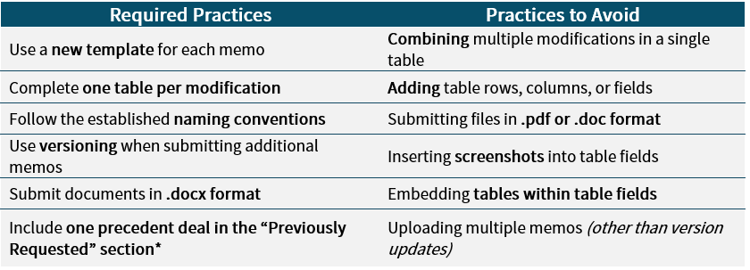

*List additional precedents in the analysis using the following format:
Sponsor Name / Deal Type / Project Name / Lender / Date Loan Closed

DRAFTING + REVISIONS
- Create new tables by selecting an entire table and then copy/paste as necessary.

- All fields, except for the date and dropdown fields, accept copy/paste, including marked text and manual entry.
Note: if manually entering text, you may need to use “shift+enter” to start a new line within the data entry box.
- Revisions to original memo submissions:
  - Submit a new version reflective of the changes only
  - Indicate the revision in the Section Reference field, examples:
Section Reference: 8.02 – Revised
Section Reference: 9.03(b)(2) – withdrawn

VERSIONING & NAMING CONVENTION
Once a memo is submitted, any changes to the original submission must be entered in a new memo and uploaded as a new version
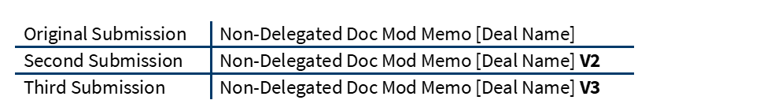
The following naming conventions must be used:

EXHIBITS/ATTACHMENTS
You may attach Exhibits and/or attachments to this Template, including marked documents.

UPLOADING/SUBMITTING MEMOS
Memos must be submitted in the .docx format
- Document Category must be: Legal
  - DO NOT select any other category when submitting a memo
- Document Type must be: Loan Document Modification Memo
  - DO NOT select any other type

ADDITIONAL INSTRUCTIONS
- A legible copy of the organizational chart that complies with the requirements under Form 6460 for the borrowing entity must be attached as Exhibit A.
- Complete Exhibit B (Additional Information) to this memorandum.
- If requesting modifications that were previously approved on a prior transaction – that prior transaction must have the same Sponsor, have closed within three (3) years of the Mortgage Loan, have similar characteristics (loan size, tier, etc.) and must be consistent with the current version of the Loan Documents.

Non-Delegated Document Modification Memo (AutoMod)

Modification Requested For:
Date: | SELECT
Project Name/Location (“Loan”): | ENTER
Lender: | SELECT
Sponsor: | ENTER
Proposed Loan Amount: | ENTER
Tier: | SELECT
Law Firm: | ENTER

Law Firm Attorney Name/Email/Phone No.:
This Modification Memo is submitted to Fannie Mae in accordance with Lender Letter 22-04 to provide an outline and analysis of certain document modifications requested by Sponsor. All capitalized terms used but not specifically defined in this memo have the same meanings assigned to such terms in Lender Letter 22-04 and the Loan Documents.

MODIFICATIONS
Non-Delegated Modification Request
Loan Document/Form Number and Publication Date | ENTER
Section Reference | ENTER
Non-Delegated Category | SELECT
Requested Modification
Analysis | ENTER
MBS Disclosure | SELECT
Was Modification previously requested? | SELECT
If Modification was previously requested, please provide the most recent transaction in which such modification was submitted, irrespective of whether it was approved or declined | Sponsor Name | ENTER
 | Origination or Assumption | SELECT
 | Approved or Declined | SELECT
 | Project Name (city/state) | ENTER
 | Originating Lender | ENTER
 | Date loan closed | Click or tap to enter a date.
 | Closing Law Firm | ENTER
 | Deal ID | ENTER
FANNIE MAE USE ONLY
Modification Decision | SELECT
Comments/Conditions | ENTER

EXHIBIT A – BORROWER ORG CHART
(REQUIRED)

MUST IDENTIFY BORROWER, KEY PRINCIPAL(S)
AND GUARANTOR(S), MANAGEMENT AND CONTROL

EXHIBIT B – ADDITIONAL INFORMATION
(REQUIRED)

Is the organizational chart attached as Exhibit A accurate, correct and complete (containing all of the information required by this memorandum, Section 4.01(a)(2) and Schedule 8 of the Loan Agreement)? | YES ☐ NO ☐ | If NO, explain why
Does the sponsor have any other loans or loan assumptions pending or recently reviewed by Fannie Mae? | YES ☐ NO ☐ | If YES,  Please provide the Deal ID Number and/or Deal Name and Lender
Is a form from Fannie Mae’s unpublished form list being requested for use? | YES ☐ NO ☐ | If YES,  Please include the name and the date received from Fannie Mae legal
Are any separate memoranda being prepared? | YES ☐ NO ☐ | If YES,  Please specify what the memorandum relates to (e.g., regulatory agreement, subordinate debt, preferred equity mezzanine debt, oil and gas lease, deed restrictions, etc.)  [If yes, please have the lender upload to Gateway]
Is a governmental agency involved in the transaction by virtue of a loan/grant, affordability restriction, tax abatement program, rent assistance program, or another reason? | YES ☐ NO ☐ | If YES,  Please include the name and role of the governmental agency
Were any checklists prepared as required by the Guide (Ground Lease, Condominium, etc.)? | YES ☐ NO ☐ | If YES,  Please have the lender upload to Gateway
Is an approved Borrower channel template being used? | YES ☐ NO ☐ | If YES,  Please have the lender upload to Gateway
Other than as flagged above, are there any other potential MBS Additional Disclosures, including post-securitization issues, to be addressed? | YES ☐ NO ☐ | If YES,  Please ensure that Fannie Mae Legal is aware
Any identified unsettled issues/concerns not yet addressed in submission? | YES ☐ NO ☐ | If YES,  Please provide additional information
Is there preferred equity in this transaction? | YES ☐ NO ☐ | If YES,  Please have the lender upload to Gateway the PE Checklist and PE governing documents
Is this an acquisition via a transfer of direct or indirect ownership interests in Borrower rather than an acquisition by deed? | YES ☐ NO ☐ | If Yes,  Please provide details of structure and mitigants to risks

